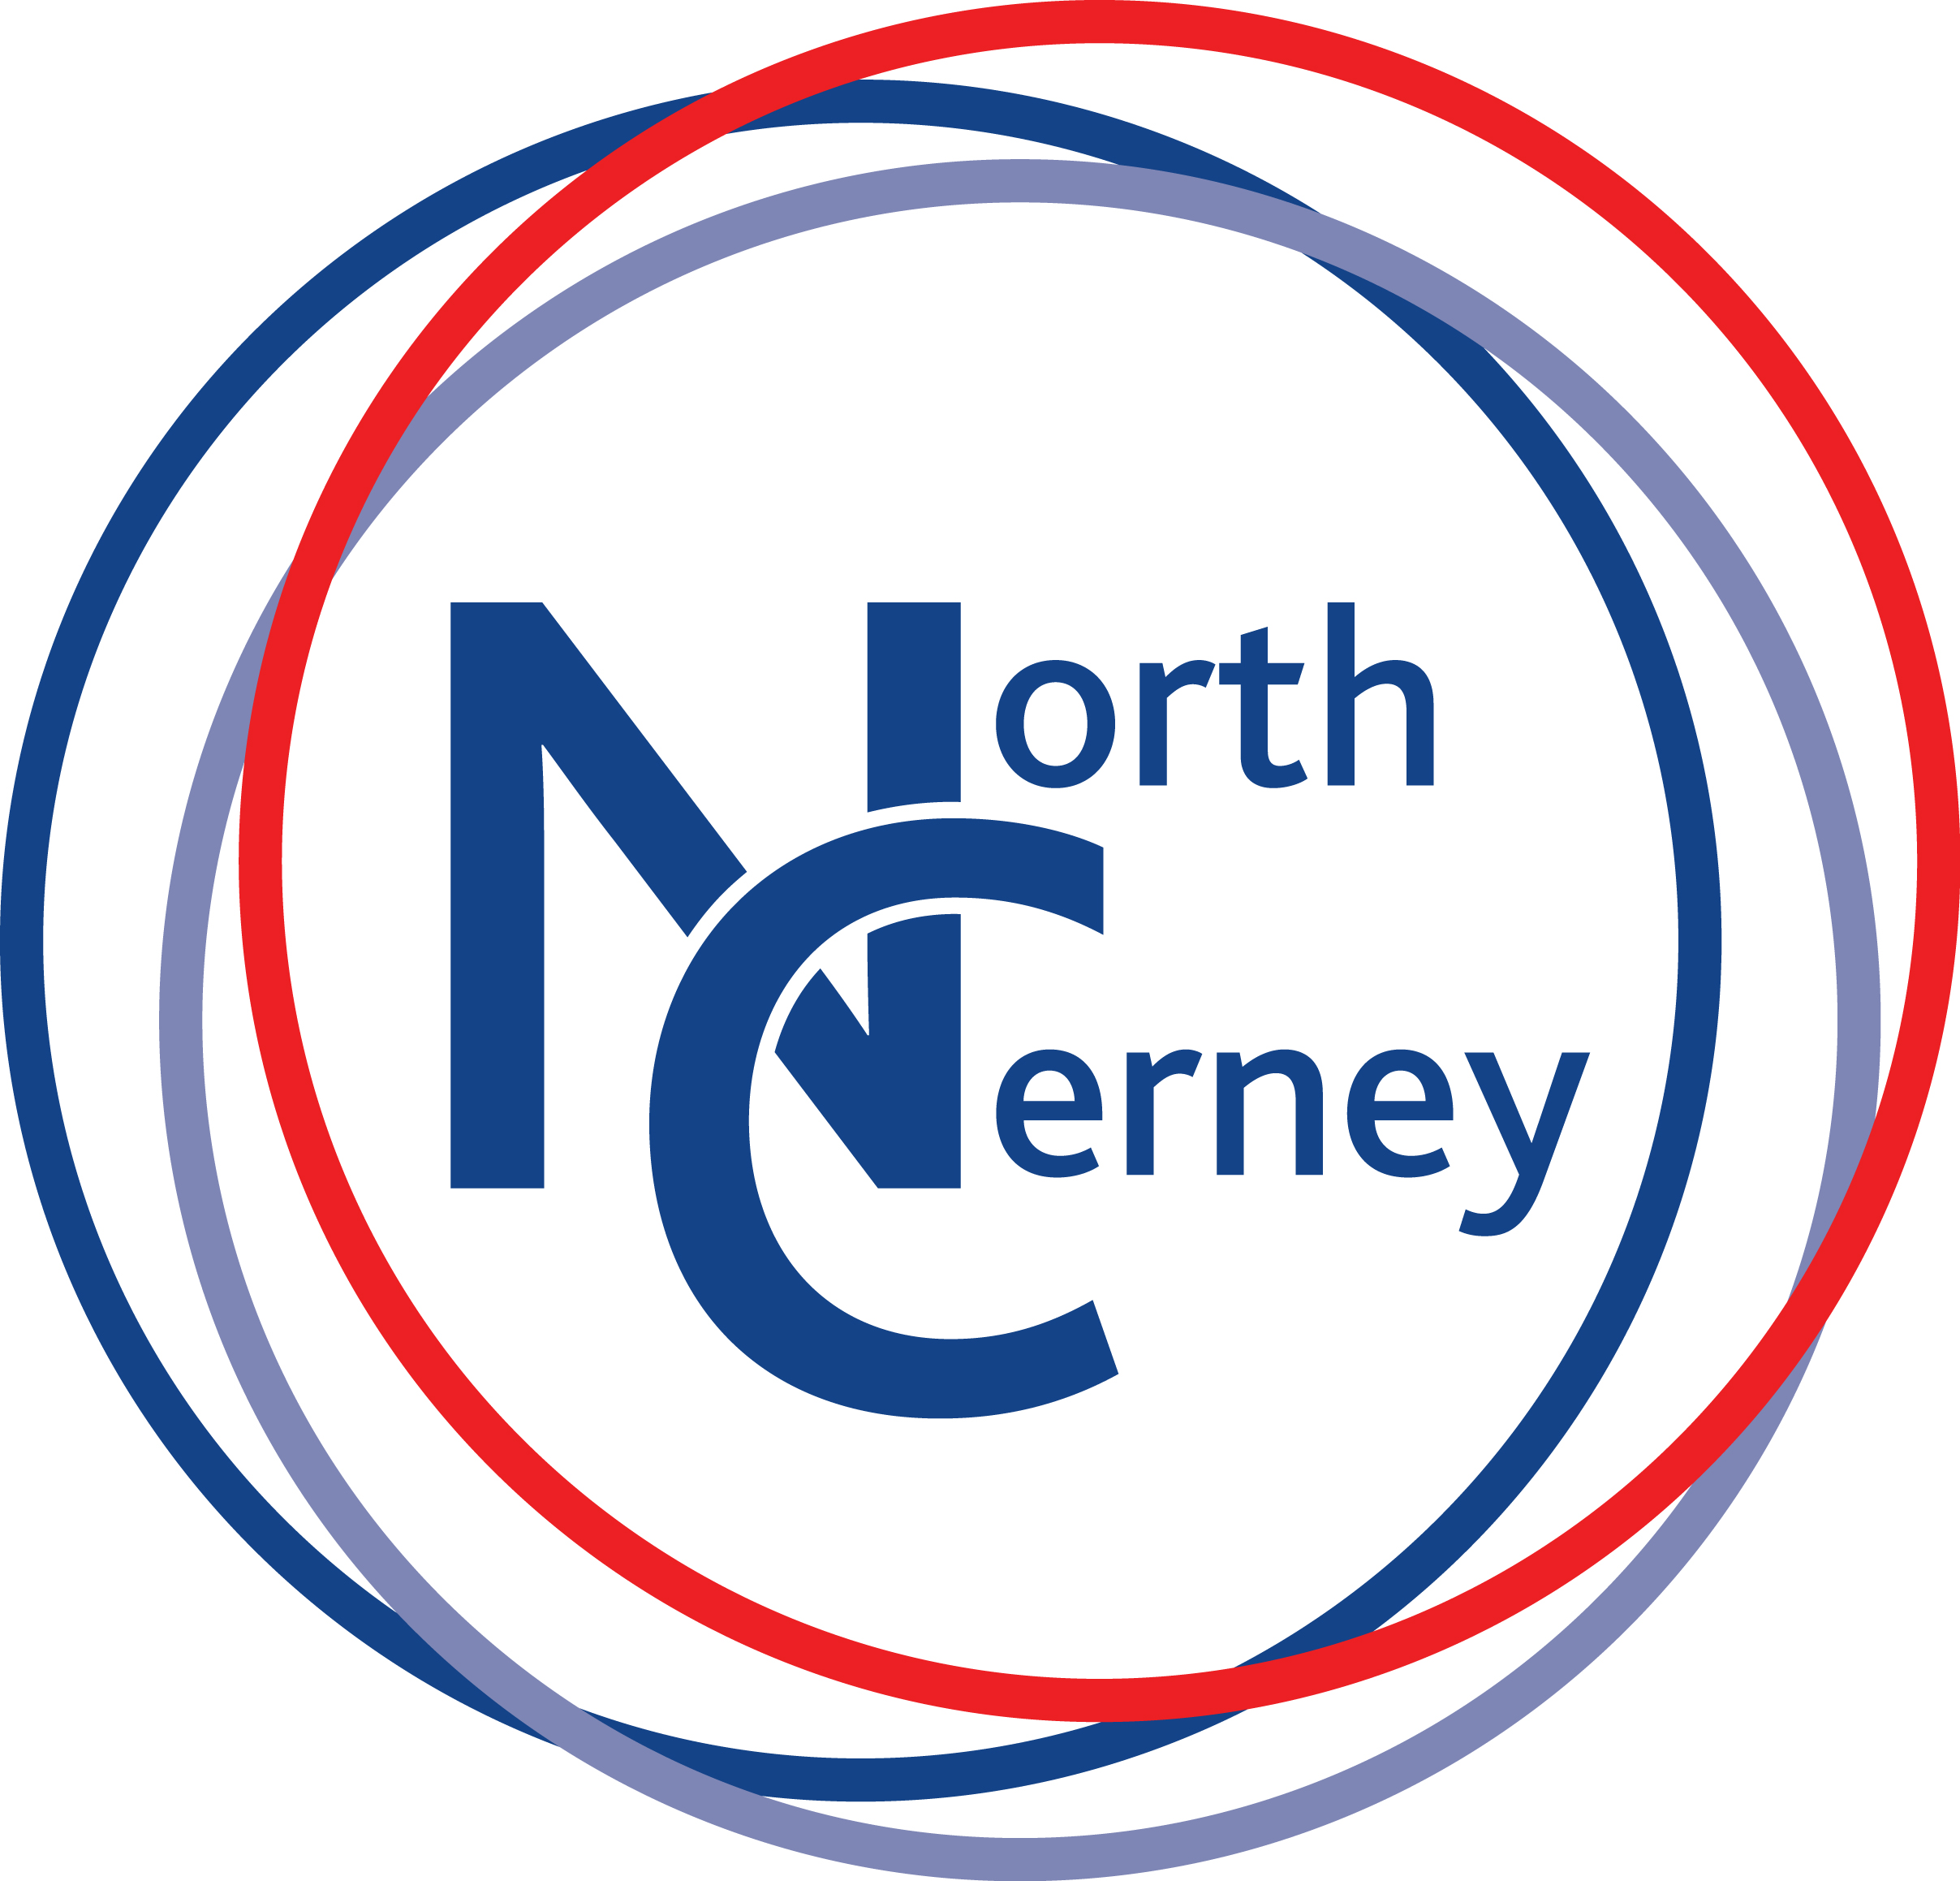

Dear Parents and Carers,

Consultation regarding conversion to ‘academy status’

As you may be aware, a while ago the governors were exploring and working closely with two local schools to convert to academy status. Due to a change of circumstances and leadership changes in one of the schools, this process has come to a stop. However the commitment of the governing body to convert to an academy remains.

I am therefore writing to inform you that, following recent investigations and careful thought, at our governing body meeting in May we voted to pursue the idea of exploring conversion to academy status within the Diocese’s Multi- Academy Trust. I attach a more detailed paper which explains further why we are minded that now is the right time to consider the change.

This letter is the start of the consultation process before any final decision is made by the governing body to convert to an academy. I would like to invite you to give feedback and specifically to ask any questions you have about our school becoming an academy within the Diocese’s Multi-Academy Trust.

Please send your views and questions to me via the school office, or by using my email address jt@thomsonandpartners.co.uk, by Monday July 13th.

In addition you are invited to an evening consultation meeting on the evening of Tuesday 21st July at the school at 6.30pm, where you can put your views and ask any further questions.

The governors have not made a final decision and this is a genuine consultation process, which will include staff, parents and carers, other local schools and organisations such as the Parish Council. The governing body does wish to hear your views, and I hope you are able to attend the meeting.

Best wishes,

Chair of Governors

