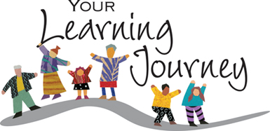
Don't be confused or misled - learning walks are really very simple. At various times through the year we offer the chance for people to come into our school to see it in operation. Without exception 'walkers' always comment on the many ways the children learn, the huge range of learning styles and opportunities in use and they usually end up saying things like 'this is very different to when I went to school,' or 'I never knew schools worked like this!'

Throughout the year Mrs Burr takes members of the governing body for a learning walk around the school. The governing body oversee the strategic operation of the school so it is important that they have a clear, first hand understanding of how the school works and how children are learning. Each learning walk focuses on a different area. The governors will spend around 10 minutes in each class. They may split up, watch and chat with the children wherever they are learning indoors or outside and they get a really good picture of the quality of learning and teaching. After each class visit the governors and Mrs Burr chat about what they have seen and ask any questions they have. By starting in Reception class and moving on to Year 6, the 'walkers' get a good idea about how learning changes as children move from one year to the next as well as the range of skills which they are learning.

Governors undertake learning walks with a focus on range of learning activities; how we develop children's thinking skills, how children learn maths, how children learn in literacy, how well our Talk for Writing program is working and how children use ICT to learn.

