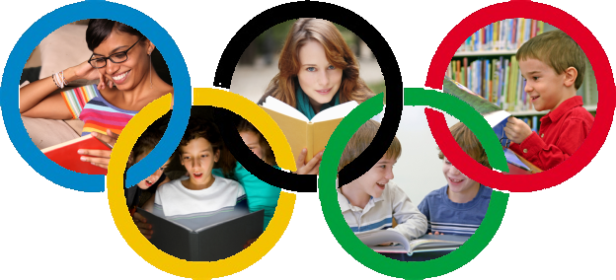
Year 6 Reading Olympiad
2012 – 2013

A guide for parents & students

The Value of Reading

During Year 6, we want to encourage students to read as often and as widely as possible. Research tells us that children who are very good and confident readers by the age of 15 are most likely to go on achieve well at high school, college and university. We also know that students who read for just half an hour a day can be up to a year ahead of those who don’t by the time they turn 15: Reading is a vital skill!

To encourage students to read more often, we are launching the reading Olympiad. We want to encourage every student to read more often, to read more widely, and to find something to love reading. We also want to encourage parents to engage with the Olympiad, both by helping their child to find and read good books, and by reading themselves.

So take up the challenge – and become a reader!

The Reading Olympiad

To encourage frequent reading, we are setting some challenges to Year 6 students, with Bronze, Silver & Gold Awards for those who do well. The challenges are set out here, and also in the reading Olympiad card that all students have been given:

2 Point Challenges
- Read a book someone else has recommended
- Recommend a book that someone else then reads
- Discuss a book with someone else who has read it
- Read a book to someone else (e.g. brother or sister)
- Write a book review

3 Point Challenges
- Learn a favourite poem by heart
- Read a ‘gift’ book from the wrapped selection
- Read a sequel to a book you’ve already read
- Read a book from the Key Authors list on page 6
- Read a book and watch the film that goes with it

5 Point Challenges
- Read a book from the Top 20 booklist on pages 4 & 5
- Read your parent’s favourite childhood book

10 Point Challenge
- Read a book from the Classics list on page 6

There may also be additional challenges through the year with bonus points awarded.

Top 20 Reading

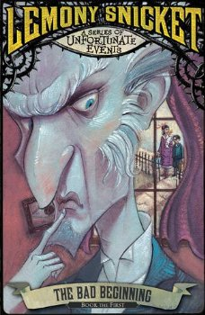 | A Series of Unfortunate Events  By Lemony Snicket  Artemis Fowl  By Eoin Colfer | 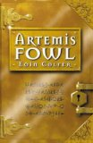
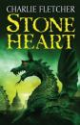 | Stoneheart  By Charlie Fletcher  Abela  By Berlie Doherty | 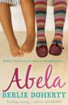
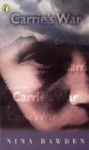 | Carrie’s War  By Nina Bawden  Charlotte’s Web  By E. B. White | 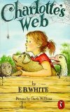
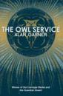 | The Owl Service  By Alan Garner  Cosmic  By Frank Cottrell Boyce | 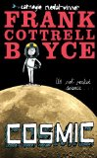
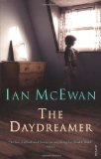 | The Daydreamer  By Ian McEwan  Diary of a Wimpy Kidd  By Jeff Kinnell | 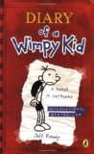
Recommendations

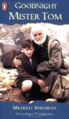 | Goodnight Mister Tom  By Michelle Magorian  How to Train Your Dragon  By Cressida Cowell | 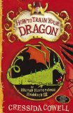
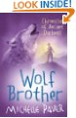 | Wolf Brother  By Michelle Paver  The Lion, the Witch & the Wardrobe  By C. S. Lewis | 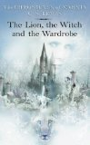
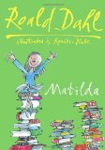 | Matilda  By Roald Dahl  Private Peaceful  By Michael Morpurgo | 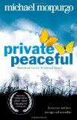
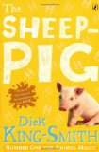 | The Sheep-Pig  By Dick King-Smith  Skelling  By David Almond | 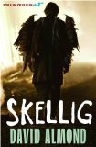
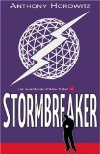 | Stormbreaker  By Anthony Horowitz  There’s a Boy in the Girls’ Bathroom  By Louis Sachar | 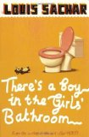
Classics
Why not try something different and go for one of these older ‘classic’ texts? Or one of the recommended authors below?
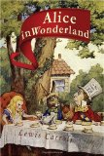 | Alice’s Adventures in Wonderland  By Lewis Caroll  A Christmas Carol  By Charles Dickens | 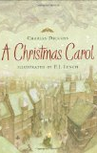
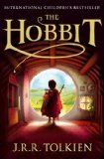 | The Hobbit  By J. R. R. Tokien  I Capture the Castle  By Dodie Smith | 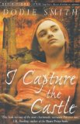
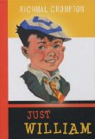 | Just William  By Richmal Crompton  Mary Poppins  By Pamela L. Travers | 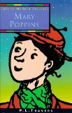
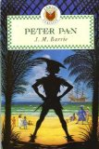 | Peter Pan  By J. M. Barrie  Treasure Island  By Robert Louis Stevenson | 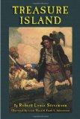
Authors

- Malorie Blackman
- Judy Blume
- Roald Dahl
- Anne Fine
- Nigel Hinton
- Anthony Horowitz
- Michael Morpurgo
- Robert Swindells
- Robert Westall
- Jacqueline Wilson

What else can we do?

There are lots of things that families can do together to support the improvement of reading ability and enjoyment – and not all of them require a book!

Talk as a family about reading
By Year 6 most students are competent readers and are less likely to read aloud to an adult. That’s a natural progression, but it doesn’t mean that parents don’t have a part to play. The higher level skills of inference and understanding the craft of an author can be supported by talking about what has been read.

Share a book
Just because you don’t necessarily read together doesn’t mean that parents and children can’t share a book. Young Adult fiction is excellent and well worth a read as a parent. Why not both read the same book?

Model what it is to be a reader
Many parents will read, whether it be fiction, newspapers, online or in any other context. Get in the habit of being seen to read, and valuing reading.

Join the library – and visit!
Library membership is free, and Cirencester library is just a short walk from the Parish Church. That opens up a whole range of reading opportunities!

Good & Bad Reading

Fiction books aren’t the only sort of reading material that will help you improve your reading ability.

Reading these will help:
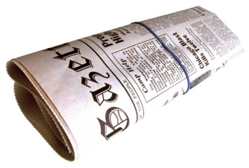 |  | 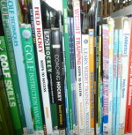
Newspapers | Websites | Non-fiction
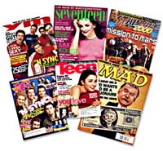 | 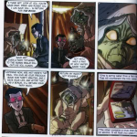 | 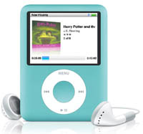
Magazines | Graphic Novels | Audio books

Reading these won’t!:
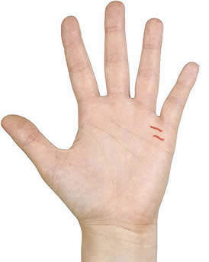 | 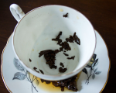
Palms | Tea Leaves

