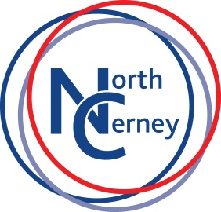
North Cerney C of E Primary School

Discover Learn Succeed

Mission Statement
“Giving our faith in their future”

School Vision
To enthuse, encourage and enable our pupils to seek challenges, explore beyond boundaries, communicate confidently and cooperatively, show initiative, self-discipline, respect and open mindedness, all within a framework of Christian values.

Ethos
The school aims to help its pupils develop as independent and co-operative learners who are able to make informed decisions, discuss their opinions with others and communicate with peers and adults easily. All pupils will be given opportunities to develop their own knowledge, personal skills, positive attitudes and values that will enable them to aspire to be lifelong learners and responsible citizens.
Pupils at North Cerney will have opportunities to learn about themselves, others and global issues including an understanding of the Christian faith.
In order to achieve these aims the school will offer experience’s that afford opportunities to develop intellectually, physically, culturally, emotionally and spiritually.

